Lab 1 - Pre Lab

ME 451 - Introduction to Instrumentation and Measurement Systems, Spring 2019

Complete the following questions for Lab 1 and submit your answers through Gradescope using the Pre Lab LaTeX template.

## Pre Lab Resources

* [Arduino guide](https://learn.sparkfun.com/tutorials/what-is-an-arduino)
* [Arduino serial reference](https://www.arduino.cc/reference/en/language/functions/communication/serial/)
* [Csv file guide](https://en.wikipedia.org/wiki/Comma-separated_values#Basic_rules)
* [Csv file guide 2](https://frictionlessdata.io/guides/csv/)

## Pre Lab Questions

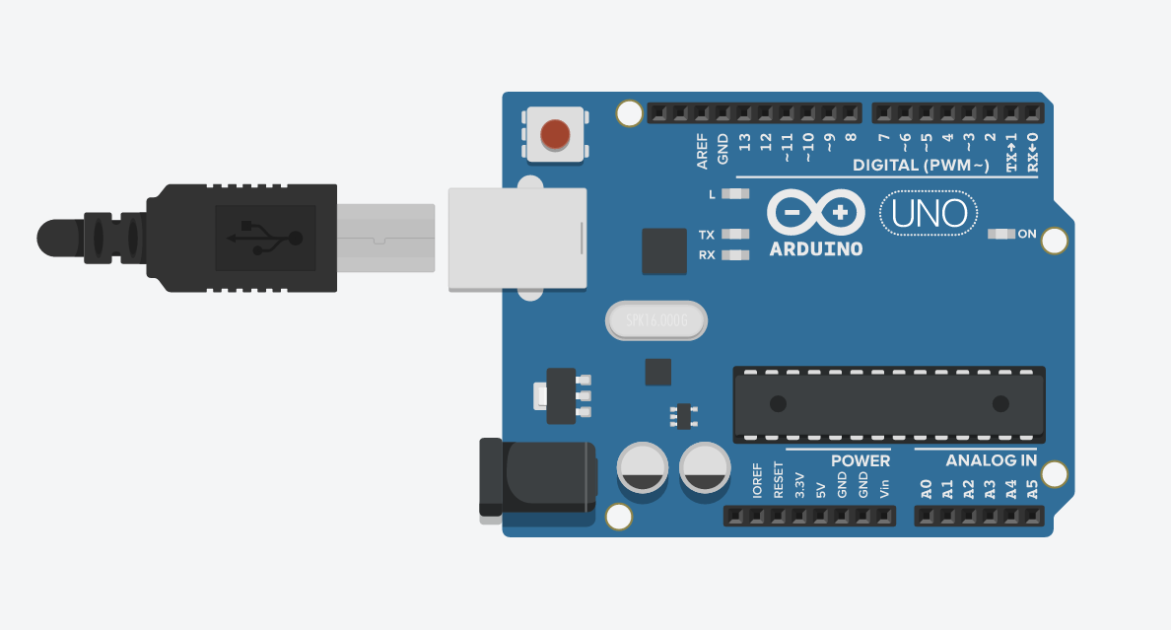

1. Provide a list of applicable pin numbers on an Arduino UNO for the following:
   1. Which can use the digitalWrite command?
   2. Which pins can use the digitalRead command?
   3. Which pins can use the analogWrite command?
   4. Which pins can use the analogRead command?
2. What is the difference between digital and analog signals?
   1. So far we have used a button and a photoresistor and in Lab 1 we will also use a temperature sensor. Which of these three sensors are digital? Which are analog?
3. What are the characters that indicate new rows and columns in a .csv file?
4. What is the difference between the serial.print, and serial.println commands?